Below highlights are to be followed for the deployment of the project.

This application is java based application. The current java LTS version 17 is used for this development.

The framework used is Spring and springboot as the RAD tool for this.

The application can be packaged as either jar or war. This guide gives detail of the deployment with war.

1. openjdk-17.0.2_windows-x64_bin is downloaded from the internet as JDK 17 is used for development of the project.
2. Apache tomcat 9 should be downloaded as the webserver. This is the container based application server that the application would be deployed on.
3. Apache tomcat 9 should be installed using the jdk 17 jvm(\openjdk-17.0.2_windows-x64_bin\jdk-17.0.2\bin\server\jvm.dll).
4. Mysql 5.8 database should be downloaded and install on the server as well. Default port should be maintained 3306. This port can be changed, if this is changed the port in the application.properties should be changed as well.
5. User name(service) and password(ZxNs1eEgb4qrcONUvGN2) should be created for the database
6. Any Mysql client should be used to test the database connectivity.
7. The attached loan-ddl-dml.sql needs to be executed on the database client environment
8. Application.properties of the project need to be modified, the IP address on spring.datasource.url needs to be changed to the IP address of the database.
9. After successful installation of the apache tomcat, attached credittest.war file should be deployed to the webapps of the apache tomcat.
10. Kindly note that the application.properties file in the exploded folder of the war file in the webapps folder needs to be changed.(IP address of the database needs to be updated.)
11. After changing the application.properties, the tomcat should be restarted.
12. After the successful restart, we should see below screen b**y calling** [**http://localhost:8080/swagger-ui.html**](http://localhost:8080/swagger-ui.html)

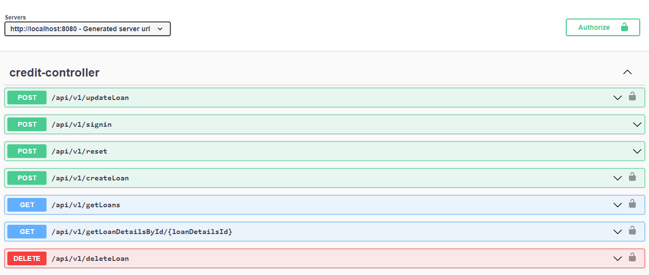

To Test the endpoints:

The endpoints can be tested using the swagger, postman or any API testing tool.

1. The first endpoint to call is reset. The username is loantester. Sample request is has shown below.

Request body

{

"userName": " loantester"

}

The response would give username and password to be used for the signin.

1. Signin is called with below request body. The response to this is the token.

The token expires after 24 hours as written in the code.

The token is passed as Bearer <token> for the Authorization header for the subsequent endpoints.